EXECUTIVE SUMMARY OF UGC MINOR RESEARCH THE PROJECT
1583-MRP/14-15/KLCA019/UGC-SWRO Dated: 04/02/2015
“Photodegradation of Polystyrene Using Nano Titanium dioxide andPhotosensitizers”-by Dr.Sunil Jose T

1. Name and Address of the Principal Investigator:Dr.Sunil Jose T
TherattilKurian House, Big Bazar. Aranattukara P.O., Thrissur, PIN - 680618
2. Name and Address of the Institution:
Dept. of Chemistry, St. Thomas’ College, Thrissur, 680001
3. UGC Approval No. And Date:
1583-MRP/14-15/KLCA019/UGC-SWRO Dated: 04/02/2015
TITLE OF THE PROJECT:“Photodegradation of Polystyrene Using Nano Titanium dioxide andPhotosensitizers”
Figure 1: Synthesis of nano TiO2 by sol-gel method and its charecterisation through FESEM and EDX analysis.
In the first stage of our work nano titanium dioxide(TiO₂)particles was synthesized using sol-gel technique and characterised using powder X-Ray diffrsction (XRD), Field emission Scanning electron microscopy (FESEM), Energy dispersive X-Ray (EDX) analysis and UV-Visible spectroscopy. Titanium tetraisopropoxide (TTIP) dissolved in ethanol was used as precursor. The obtained TiO₂ powder was calcinated at 400C for 2 hours in Muffle furnace inorder to increase its crystallinity. XRD patterns exhibited the characteristic peaks corresponding to anatase and rutile phases of TiO₂. Anatase phase predominated the rutile phase. The average particle size was determined to be around 25 nm from SEM.Various percentages of the synthesised nano TiO₂ was loaded into polystyrene (PS) matrix through solvent casting method. For this the PS pellets dissolved in toluene and to which nano TiO₂ was added and homogenized using an ultra sonicator probe (750 W). The solution was now casted into thin sheets over petridishes and dried. The PS as well as PS-TiO₂ composite sheets were subjected to UV radiation for 2000 hours with the aid of a UV tube (30 W, 253 nm) fixed inside a wooden chamber. The polymer specimens were monitored periodicallyafter regular intervals (500 hr) of UV irradiation. Gel permeation chromatography (GPC) analysis was used to determine the change in average molecular weights of the specimens before and after UV irradiation. It was observed from the GPC analysis that the average molecular weights decreased upon UV irradiation due to the polymer chain deterioration as a consequence of photodegradation. From the FTIR spectra of the polymer specimens the occurance of photo-oxidative degradation was quiet clear. UV-vis spectroscopy of the specimens further supported photodegradation exhibiting the lowering of intensities of the characteristic absorption bands of PS in the UV region with a red shift upon UV irradiation. The mechanical properties including tensile and flexural strengths decreased as a consequence of photodegradation upon UV exposure. The dielectric strength of the composites decreased due to the formation of conductive charge carriers upon UV irradiation. Accounting all the monitoring techniques used it was evident that PS-TiO₂ composites underwent accelerated photodegradation upon UV irradiation compared to pristine PS.
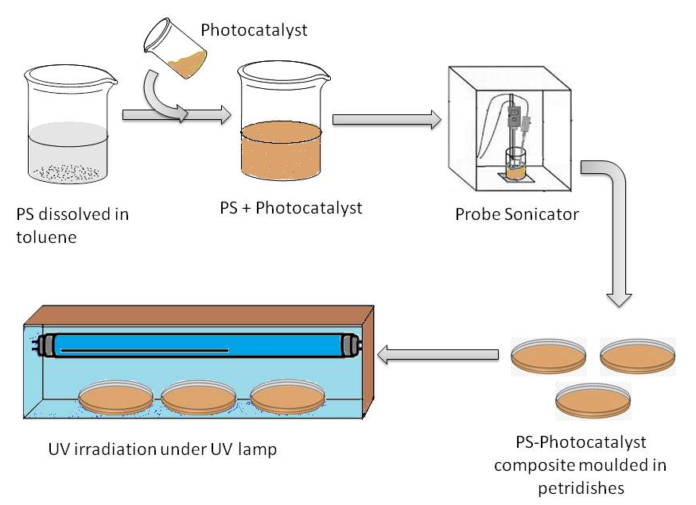
Figure 2: PS composite sheet caasting and photodegradation setup

In the second phase of our investigation, the role of photosensitizers in the photodegradation of PS individually and in coupled state with TiO₂ is examined. The photosensitizers chosen for our study was benzophenone (BP) and benzophenone derivatives namely 4-methoxy benzophenone (4MBP), 2-hydroxy-4-methoxy benzophenone (2H4MBP), 4-nitro benzophenone (4NBP) and 2-chlorobenzophenone (2ClBP). It was observed that the photodegradation of PS was accelerated when BP, 4MBP and 2ClBP were used as photocatalysts. 4NBP, 2H4MBP on the other hand showed no significant acceleration in the photodegradation of PS. BP is a well established photosensitizer which absorbs UV radiation leading to the homolytic cleavage of the π-bond of its carbonyl (-C=O) group producing radicals at carbon and oxygen atoms. In the case of 4MBP and 2ClBP, the presence of methoxy (-OCH₃) as well as chloro (-Cl) groups attached to the phenylic rings of benzophenone moiety increases the resonance of the system there by stabilizing the newly produced radicals. The interamolecular H-bond between –OH and C=O groups of 2H4MBP which resulted in dissipation of absorbed UV light and deactivation of its excited state made it more photostabilizer. In the case of 4NBP, the nitro group (-NO2) decreases the resonance of the benzene rings of benzophenone moiety thereby reducing the stability of the radicals formed leading to a decrease in its photocatalytic activity. Benzophenone derivatives coupled with nano TiO2 exhibited further acceleration in the photdegradation of PS .
Paper published from this minor project
Journal paper
- Dinooplal, S., Sunil Jose, T., & Rajesh, C. (2019). "Solid-phase photodegradation of polystyrene by nano TiO2 under ultraviolet radiation". Environmental Nanotechnology, Monitoring & Management, 12 (May), 100229. https://doi.org/10.1016/j.enmm.2019.100229

International conference presentations
- Dinooplal S, Sunil Jose T, Rajesh C, “Photocatalytic Degradation of Solid Phase Polystyrene Using Nano TiO₂ and 2-Hydroxy-4-methoxybenzophenone.” International Conference on Molecular Spectroscopy-2017 , Mahatma Gandhi University, Kottayam.
- Dinooplal S, Sunil Jose T, Rajesh C, “Photodegradation of Solid Phase Polystyrene by Nano Titanium dioxide and Photosensitizers under Ultraviolet Radiation.” International Conference on Chemistry and Physics of Materials 2018. St.Thomas’s College, Thrissur.

