EXECUTIVE SUMMARY OF UGC MINOR RESEARCH THE PROJECT
1582-MRP/14-15/KLCA019/UGC-SWRO dated 04/02/2015
“Synthesis and characterization of self doped conducting polymers and their copolymers” - by Dr. Jinish Antony M
1. Name and Address of the Principal Investigator: Dr.Jinish Antony M
Mecnachery House, Amala Nagar P.O., Thrissur, 680555
2. Name and Address of the Institution:
Dept. of chemistry, St. Thomas College, Thrissur, 680555
3. UGC Approval No. And Date:
1582-MRP/14-15/KLCA019/UGC-SWRO dated 04/02/2015
TITLE OF THE PROJECT: Synthesis and characterization of self doped conducting polymers and their copolymers”

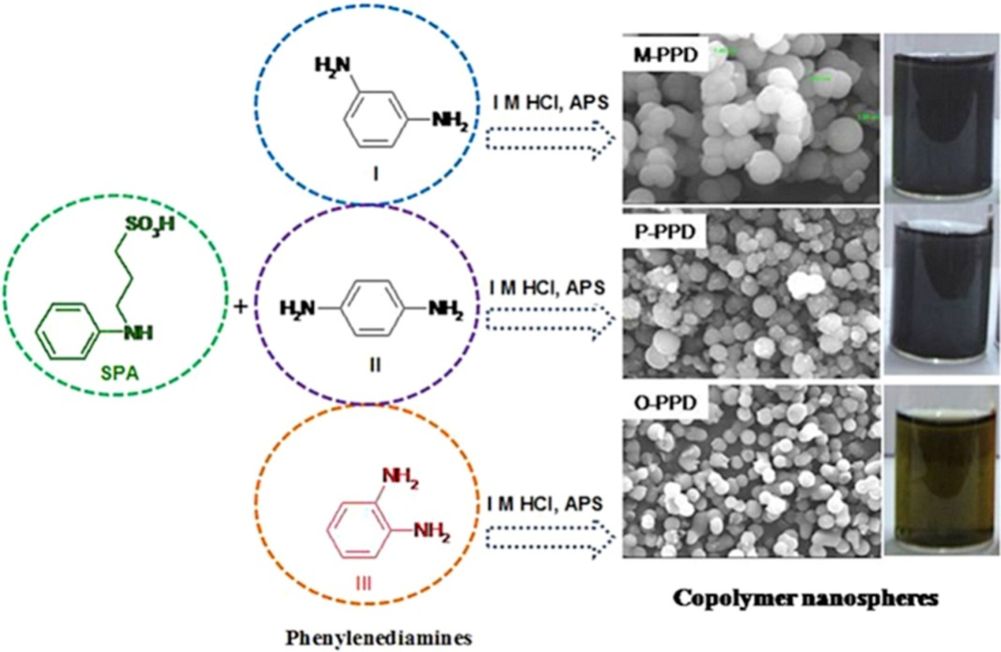

Figure 1. Synthesis of PSPA, Poly-x-PD and random copolymers
In the first phase project work the homopolymers of poly-phenylenediamines (P-PD’s) and poly-N-sulfopropyl aniline (PSPA) were synthesized via chemical oxidative polymerization of phenylenediamine monomers and sulfopropyl aniline using ammonium persulfate as oxidizing agent in acidified medium. Three homopolymers of phenylenediamines synthesised were poly (m-phenylenediamine) P-MPD, poly (p-phenylenediamine) P-PPD and poly (o-phenylenediamine) P-OPD. Poly-N-sulfopropyl aniline (PSPA) is a self doped water soluble conducting polymer. Random copolymerization of N-sulfopropyl aniline and phenylenediamines would enhance the solubility of the copolymer nanomaterials. Three different copolymer compositions (COP25, COP50 and COP75) were employed for copolymer synthesis based on weight percentage of co-monomers feed.

Figure-2 Solubility’s of PSPA, Poly-x-PD and their randomcopolymers
In second phase of the project, homopolymers and copolymers were characterized by fourier-transform infrared spectroscopy (FT-IR) and elemental analysis. The uv-visible absorption spectra of the samples in water were shown the characteristic polaron- π* and π-π* peaks. The solid state ordering of the samples recorded by powder wide angle x-ray diffraction studies reveals that homopolymer samples were partially crystalline, whereas copolymers were either amorphous or less crystalline than homopolymer. Morphological features of the polymers and copolymers were recorded by scanning electron microscope (SEM). Poly (m-Phenylenediamine) was uniformly distributed submicron spheres with an average size of 850± 50 nm, whereas the poly (p-phenylenediamine) non-uniform spheres with size in the range 600-100 nm. The P-OPD sample was highly crystalline and shown some ordered rod like structures. Interestingly, all copolymer samples like M-COP25, P-COP25, and O-COP25 were formed as uniform submicron spheres. Poor water solubility of poly-phenylenediamines in aqueous solution was substantially improved by copolymerization.
Paper published from this minor research project:
- KR Das, MJ Antony, Synthesis and characterisation of water dispersible copolymer submicron spheres of poly-(phenylenediamine-co-N-sulfopropyl aniline) via random copolymerisation, Polymer 87 (2016) 215-225. International publication of JCR impact factor 3.56 https://doi.org/10.1016/j.polymer.2016.01.078
- T. S. Swathy, M. Ann Jose, M. Jinish Antony, AOT assisted preparation of ordered, conducting and dispersible core-shell nanostructured polythiophene – MWCNT nanocomposites, Polymer, Vol. 103, October 2016, pp. 206-213. [Impact factor; JCR, 3.68] https://doi.org/10.1016/j.polymer.2016.09.047

